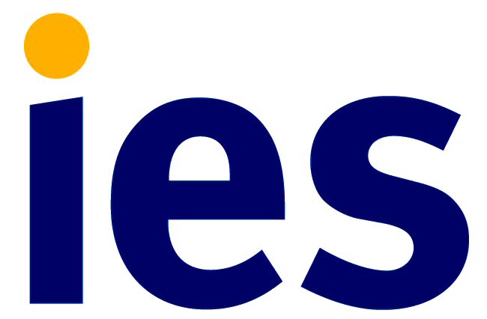
Equal Opportunities
We are committed to our equal opportunities policy. The aim of our policy is to ensure that no job applicant or employee receives less favourable treatment on the grounds of age, disability, gender reassignment, marriage and civil partnership, pregnancy and maternity, race (including colour, nationality, ethnic or national origin), religion or belief, sex, sexual orientation, or is disadvantaged by conditions or requirements which cannot be shown to be justifiable.
Suitability to the job is our sole criterion for selection or promotion in IES. All employees are given opportunity to develop and are encouraged to progress within the organisation. In order to monitor our policy it would be very helpful if you would complete the details below. Completing this page forms no part of our selection procedure.
For the purposes of compliance with the Data protection Act 1998, I hereby confirm that by completing this form I give my consent to IES processing the data supplied on this form for the purposes of equal opportunities monitoring.

Please tick the box Job applied for Date

Ethnicity
What is your ethnic group? Choose ONE section from A to E, then tick the appropriate box to indicate your cultural background. Classification recommended by the Equality and Human Rights Commission (EHRC)

A. Asian or Asian British

Bangladeshi

Indian

Pakistani

Any other Asian background Please write in
B. Black or Black British

African
Caribbean

Any other Black background Please write in
C. Chinese or other ethnic group

Chinese

Any other Please write in
D. Mixed heritage

White and Black Caribbean
White and Black African
White and Asian

Any other mixed background Please write in
E. White

British
English
Irish
Scottish
Welsh

Any other Please write in

F. Prefer not to say

Gender

Female Male Unspecified Prefer not to say

Sexual orientation

Bisexual Gay man Gay woman/lesbian Heterosexual/straight Other Prefer not to say

Age

Your age Prefer not to say

Disability

Do you consider yourself to have a disability or a long term health condition? Yes No Prefer not to say

If yes, what is the effect or impact of your disability or health condition? Prefer not to say

What adjustments, if any, can we make to assist your application?

Religion

Buddhist Christian Hindu Jew Muslim Sikh No religion Prefer not to say

Other religion or belief (please specify)

